Day 6 - 104608492 - Shirisha Perapagu

Task 1 – Regular Expressions

Regular expressions search for matched patterns.

It can replace text, extract data and search for things like phone numbers, email via certain pattern.

Symbols used:

. Matches any single character. Ex: a.bc matches azbc, , a2bc, a$bc etc.

\d Matches a decimal digit character (i.e. 0-9). Ex: a\d matches a1, a2, a3 etc. but not aa, ab

\D Matches a non-digit character. Ex: a\D matches ab but not a1, a2, a3

\s Matches any whitespace character (space, tab, newline). Ex: ab\sd matches ab d but not abcd

\S Matches any non-whitespace character. Ex. ab\Sd matches abcd, abxd but not ab d

\w Shorthand for [a-zA-Z0-9_]. Matches any alphabetical or digit character, or underscore.

* 0 or more of the previous character. Ex a* matches “”(null),a, aa, aaa

+ 1 or more of the previous character. Ex a+ matches a, aa, aaa

? 0 or 1 of the previous character. Ex a? matches “”(null),a

^ Start of string Ex. ^Hello matches string starts with “Hello”

$ End of string Ex. World$ matches string that ends with “World”

Task 2 - Linux Features

1. It is an open-source OS. No license fee required.
2. It supports File Systems to store, organize and manage files and folders.
3. The Terminal can control whole system with commands.
4. It helps in multitasking. It can run many programs at same time like play music and download files etc.
5. It is secured. It provides controlled access through user permissions and user roles.

Task 3 – Kernel

Kernel is a part of OS which connects computer’s hardware like CPU, memory, devices to software like app, other programs.

It acts a mediator between software and hardware.

It controls hardware to talk to devices like keyboard, mouse etc.

It also controls user access and system permissions.

It also controls how RAM should be used by apps.

Without Kernel, apps won’t know how to use memory, use external devices like printer or save files etc. It runs in the background.

Task 4

BASH stands for Bourne Again Shell.

It is the default shell mostly used. It lets you interact with your computer using text commands.

It supports all sh features.

It has many improvements than older shell(Bourne Shell) like command-line editing (vi), command history, arithmetic operations, scripting part etc.

It can run programs, manage files and folders and can automate tasks like making backups.

Task 5

Difference between Linux and Windows

1. Linux is open-source anyone can see and change its code but windows is closed-source which only Microsoft controls it.
2. Linux is free, while windows cost money to use.
3. Linux is great for programmers or techies who controls and windows is better for beginners for everyday tasks like games, word, excel.
4. Linux is used on severs while windows is common in home and office computers.

Task 6

Basic components of Linux

1. Kernel - controls hardware and software and manages how software talks to hardware.
2. Shell - the command interpreter which allows to give commands to the system and converts commands into acts. Ex. BASH
3. File System - organizes and stores files be it documents, programs etc.
4. System Libraries - pre-made code helpers used by programs to do common tasks like saving a file.
5. System Utilities - small programs or tools that do specific jobs. Ex. ls to list files, cp for copy files.
6. Users Management - controls who can do what on the system. Users, groups and permissions help keep the system secure.

Task 7

Is it legal to edit Kernel? when do you think we have to in case?

Yes it is legal to edit the Linux kernel as it is released under GNU General Public License(GPL). It is open source and free to modify.

When we need to edit the Kernel:

1.When we require to add support for new hardware

If we are building a device like a router and the hardware is new, we might to write drivers to recognize it.

2. When we require research or learning

Developers and students often edit the kernel to learn how operating systems work.

3. When we want to create custom operating systems

Projects like Android are built on modified versions of Linux versions.

4.When security research is needed

Security experts may edit the kernel to test and fix bugs.

Task 8

What is LILO?

LILO stands for Linux Loader.

It is a boot loader for Linux – a small program that starts the OS when we turn on our computer. Basically, it helps start your Linux system.

When we on our PC

1. BIOS starts first which is basic hardware check.
2. LILO loads the Linux Kernel into memory.
3. The kernel takes over and starts the Linux system.

LILO is like middleman that helps boot Linux from hard disk.

It is no longer the primary boot loader used in most modern Linux distributions. It has been largely replaced by GRUB.

Task 9

What is Shell in Linux

A shell is a program that will let us interact with OS like Linux using commands.

It acts as translator between user and Linux system. So, we write commands like mkdir, cd etc. and the shell will send them to OS to run.

There are several types of shells.

1. Bourne shell (Sh) - it is the original Bourne shell which is the oldest and simple and widely used for scripts.
2. Bourne Again Shell (Bash) - the most widely used shell in Linux systems, known for its features and versatility.
3. Z Shell (Zsh) - a highly customizable shell with features like auto-completion and extensive scripting capabilities.
4. Fish Shell (Fish) - designed for ease of use, with features like syntax highlighting and automatic suggestion.
5. Bourne Shell (sh) - a legacy shell that served as the foundation for other shells.
6. C Shell (csh) - a shell with syntax similar to the C programming language.
7. Korn Shell (ksh) - a shell that combines features from other shells and is used in various systems.

Task 10

What is swap space?

Swap space, also known as virtual memory, is a storage area on a computer's hard drive that acts as an extension of its physical RAM.

It is used when the RAM is full, temporarily storing inactive data that is not immediately needed, preventing system crashes due to memory shortages.

Task 11

What is Mount ? how do you mount and unmount file system in Linux?

In linux, mounting means making a storage device like USB drive, hard disk, ISO Files available so we can access its files.

Ex. We can plug in a USB drive, but until its mounted we can’t open or use it.

Linus doesn’t auto assign it instead it uses mount points i.e. folders where the device content appears.

/mnt

/mnt/usb

In short

Mount – making a device usable (attach it to a folder)

Unmount – saferly remove/disconnect it.

How to Mount a file system

1. Create a mount point a folder

Sudo mkdir /mnt/mydrive

1. Mount the device

Sudo mount /dev/sdX1 /mnt/mydrive

Replace /dev/sdX1 with our actual device like /dev/sdb1

1. Access the files

cd /mny/mydrive

ls

what is mounted we can check with mount command or df -h or lsblk

How to unmount a file system

Unmounting disconnects the device safely.

sudo unmount /mnt/mydrive

Or we can use device name

sudo unmount /dev/sdX1

Task 12

The chmod command in Linux is used to change the permissions of files and directories, controlling who can read, write, and execute them. It can be used in two main modes: octal or symbolic.

Octal Mode

Octal mode uses a three-digit number to represent permissions. Each digit represents permissions for the owner, group, and others, respectively. The digits are:

4: Read permission

2: Write permission

1: Execute permission

7: Read, Write, and Execute (4 + 2 + 1)

6: Read and Write (4 + 2)

5: Read and Execute (4 + 1)

0: No permission

Ex. chmod 755 myfile.txt

This command gives the owner read, write, and execute permissions (7), the group read and execute permissions (5), and others read and execute permissions (5).

Symbolic Mode

Symbolic mode uses letters and symbols to represent permissions. The syntax is:

chmod [who] [operator] [permission] [filename]

who - Specifies the user or group to modify the permissions for (u=user, g=group, o=others, a=all).

Operator - Specifies how to modify the permissions (+ = add, - = remove, = = set).

Permission - Specifies the permissions to add or remove (r=read, w=write, x=execute).

Ex. chmod u+x myfile.txt

Task 13

Add user accounts

1st way with adduser

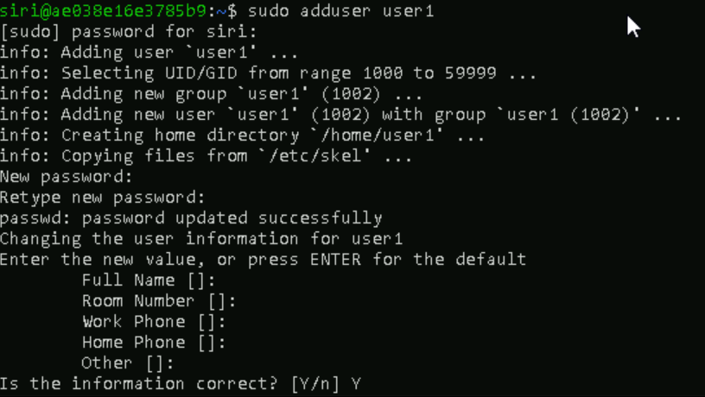

2nd way - useradd

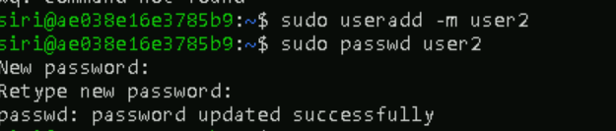

3rd way single command: both adding user and pwd



Task 14

Can you change the password of a user?

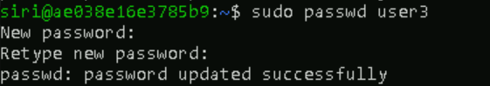

Task 15

A process is a program in execution, while a thread is a unit of execution within a process.

Processes are independent, with their own memory space, while threads within the same process share memory and resources.

Threads are lighter than processes, meaning they require fewer resources and have faster context switching.

One process crash won't affect others, a thread crash might affect the entire process.

Task 16

Grep commands

Input File (TestFile10.txt) content:

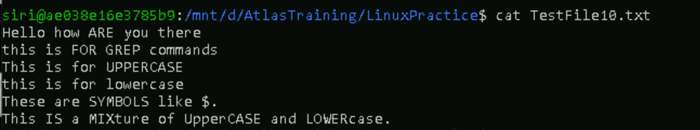

1. Case insensitive search

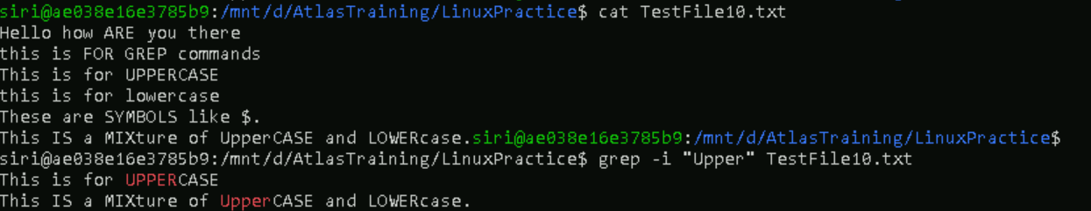

1. Displaying the Count of Number of Matches Using grep

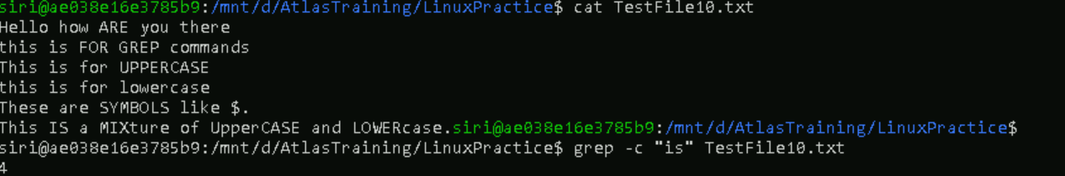

1. Display the File Names that Matches the Pattern Using grep

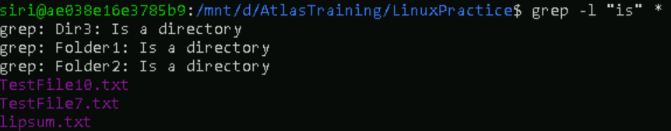

1. Checking for the Whole Words (case insensitive) in a File Using grep



1. Displaying only the matched pattern Using grep



1. Show Line Number While Displaying the Output Using



1. Inverting the Pattern Match Using grep

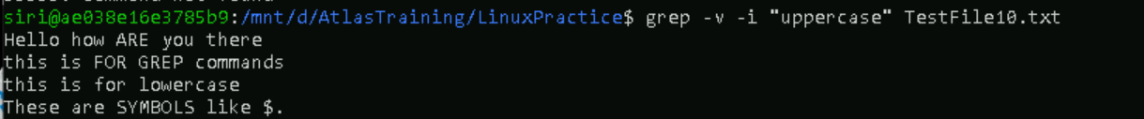

1. Matching the Lines that Start with a String Using grep

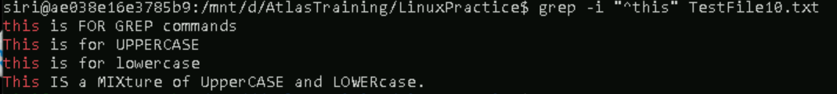

1. Matching the Lines that End with a String Using grep



1. Specifies expression with -e option



1. -f file option Takes patterns from file, one per line

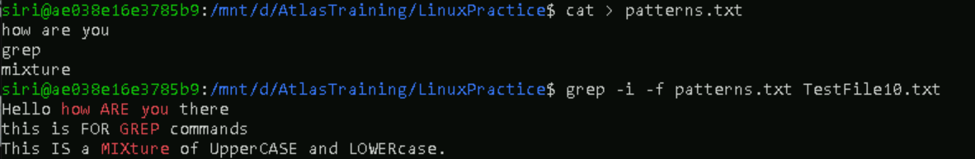

1. Print n Specific Lines from a File Using grep

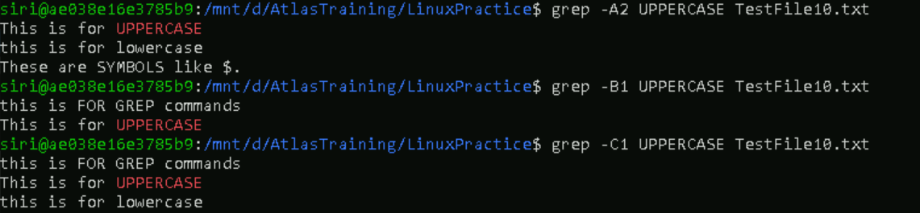

1. Search Recursively for a Pattern in the Directory

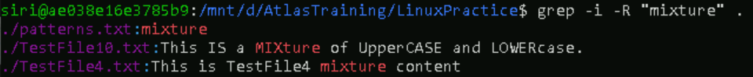

AWK commands

1. Print Contents of a File
2. Print Specific Columns of a File

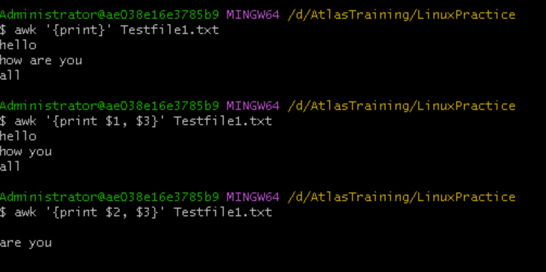

1. Filter Lines Based on a Condition

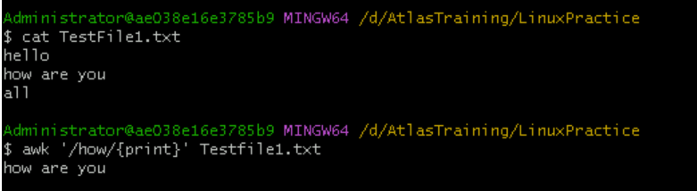

1. Sum Values in a Column

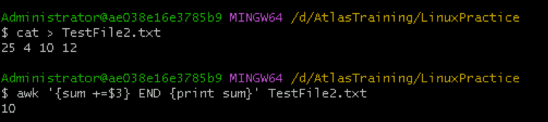

1. Extract Substring from a Column

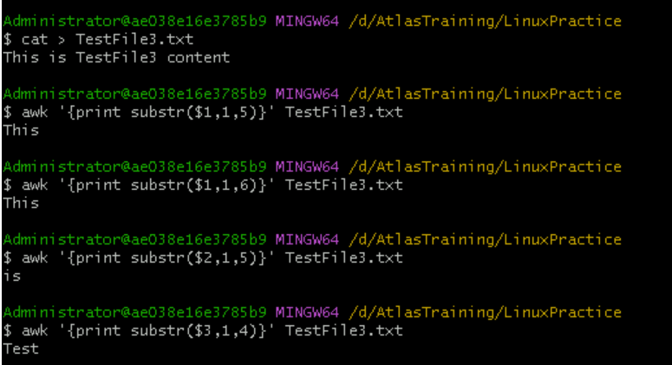

1. Join Two Files Based on a Common Column

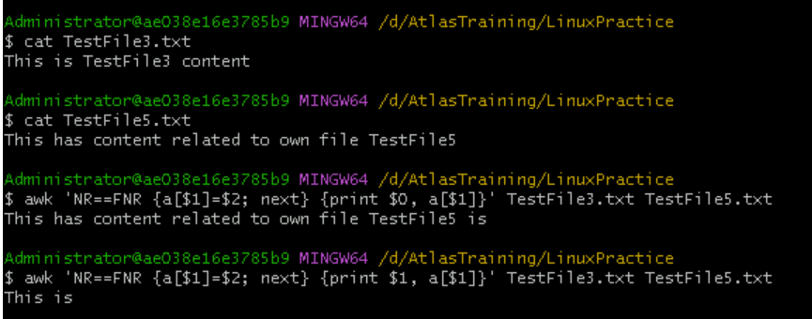

1. Extract First Column of a File

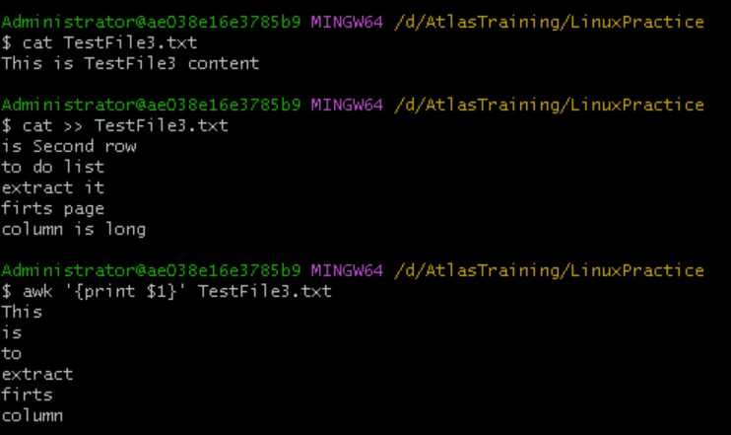

1. Calculate Average of a Column

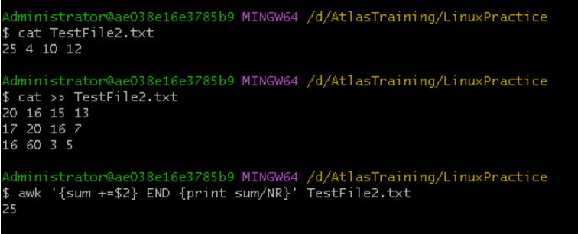

1. Replace a String in a File

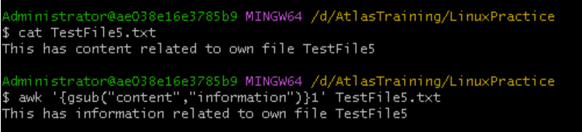

1. Display Last Field of a File

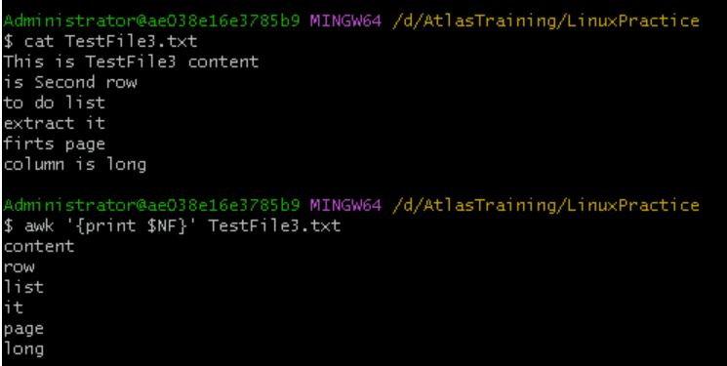

1. Using Regular Expressions

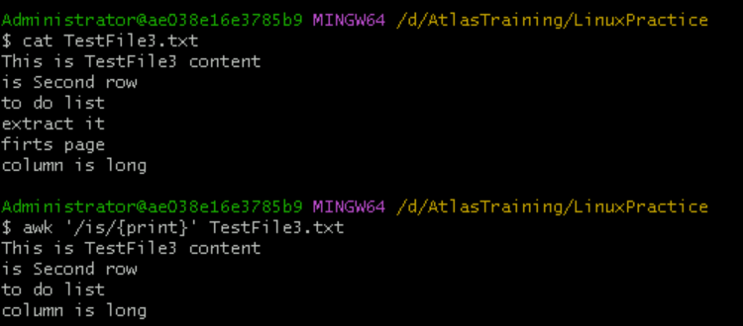

1. Using Variables

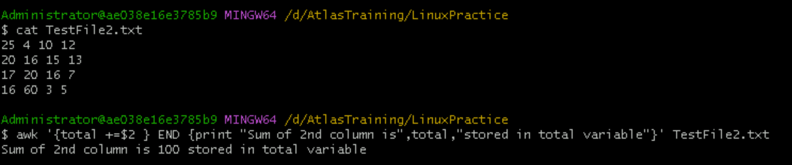

1. Using Built-in Variables

FS – Field Separator

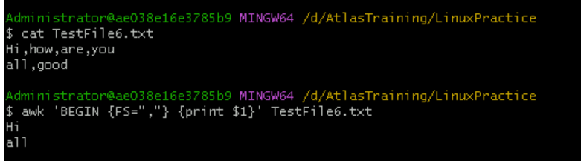

RS – Record Separator

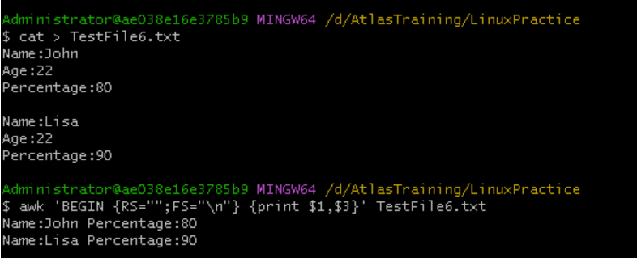

1. Using Control Statements

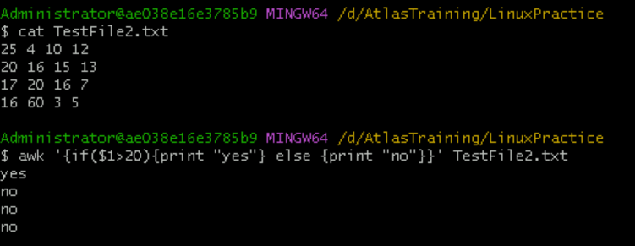

1. Using Functions

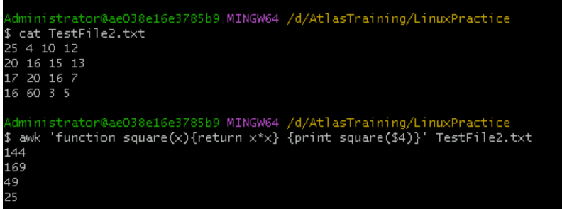

Task 18:

How to check file access permission in Linux?

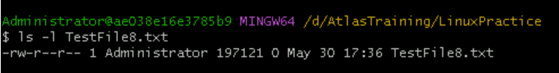

Task 19

Default permissions for a new file

When we create a new fie, linux gives it default permissions.

Base permission is always 666 i.e rw-rw-rw-

Owner : rw- read and write

Group : rw- read and write

Others: rw- read and write

Task 20

command to change the permisssion to read only for the owner, group and all other users

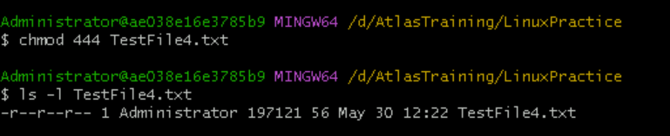

Task 21

change the file permissions to match the following:

* owner: Read and Write
* group: Read
* other: no permissions (None)

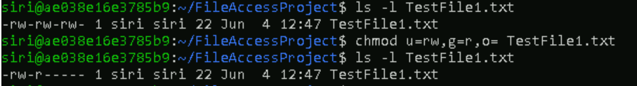

Task 22:

What was the command for changing the file permissions to -rw-r-----?

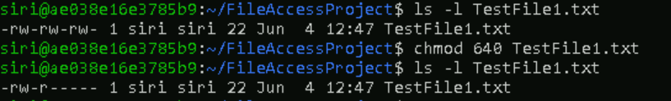

Task 23:

Change file cpermissions to -rwxr-x--x

Change the file permissions to match the following:

owner: Read, Write and Execute

group: Read and Execute

other: Execute

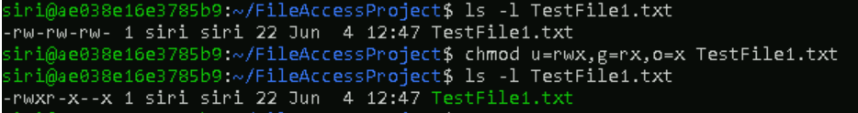

Task 24

What was the command for changing the file permissions to -rwxr-x--x

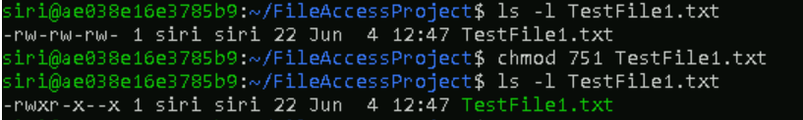

Task 25

What will this command do?

chown -c master file1.txt

It will change the ownership of file1.txt to the new owner master.

chown – used for changing the ownership of file1.txt

-c – “changes” option will make chown to show output like “changed ownership of file1..” only if file’s ownership is actually being changed.

master – the new owner of file1.txt

file1.txt – the target file whose ownership is being changed

Task 26

What is a process?

A process is an instance of a program in execution or simply it is a running program.

When we run a program like opening a file, starting a browser or running any command say dir, the operating system will create a process to handle the program.

Task 27:

What is command to check foreground process and background process

jobs

Task 28:

Can you list all the running processes?

Yes, by using ps command

Task 29:

What will ps -f command do ?

Shows full format listing of processes running in current user.

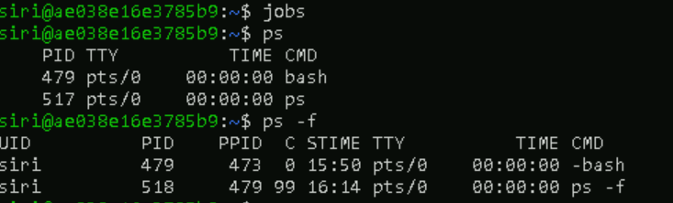

Shell Variables

Task 30: a)create a variable named name and added name in it

b) displayed the name by using echo

Task 31: make it readonly variable hence assigning any other name shows error

Task 32 : to delete a variable we can use unset, but since name is readonly, it can’t delete it. It gives error.

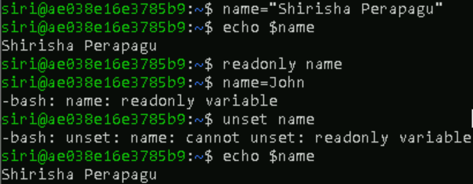

We need to start a new shell session to remove variable

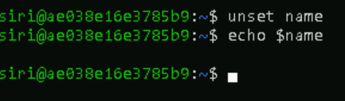

Task 33:

Add a list of your friends names in an array and print.

-array name is friends_names

Task 34:

print all the list at once in an array

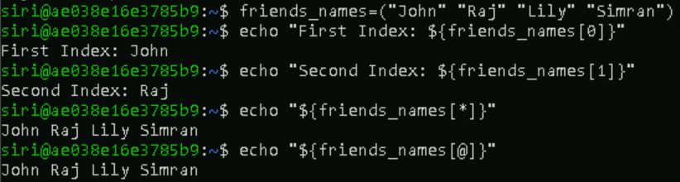

Task 35:

What is the output of the below snippet:

a=0

while [ "$a" -lt 10 ]    # this is loop1

do

   b="$a"

   while [ "$b" -ge 0 ]  # this is loop2

   do

      echo -n "$b "

      b=`expr $b - 1`

   done

   echo

   a=`expr $a + 1`

done

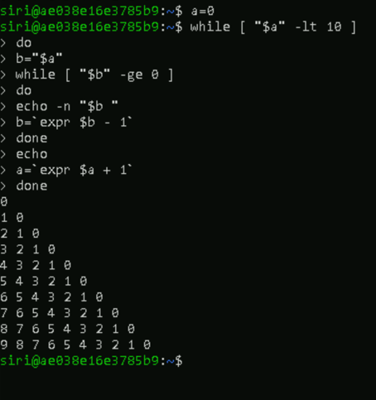

Symbolic link file

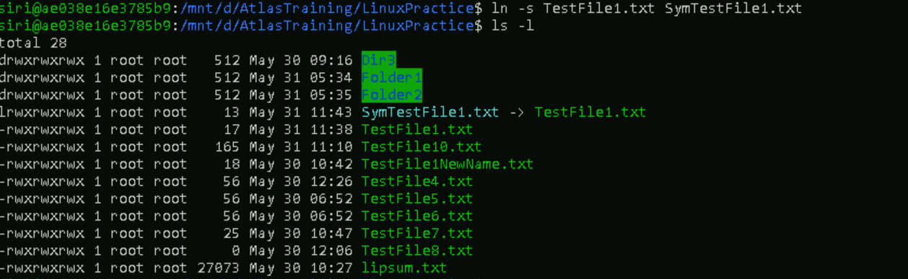

Changes in symbolic link file(SymTestFile1.txt) effecting in original file(TestFile1.txt)

